**Some Noticeable Problems with Course Builder and App Engine**

It seems that the Course Builder and App Engine are more compatible with the MAC and Linux environment than the Windows. Even some of the instructions stated and recommended in the Course Builder and App Engine wiki and documentation pages do not work properly. For instance, instructions for downloading course and datastore information, as stated in the following wiki page of the course builder documentation page do not work in Windows OS.

<https://code.google.com/p/course-builder/wiki/ExportCourseData>

In order to Export Course Data from the App Engine cloud server the Course Builder recommends to configure the file paths by creating a python program file named *gcbpaths.py,* save that into the \tools\etl folder, and run a command line statement with the following format.

python tools/etl/gcbpaths.py download course <course_url_prefix> <app_name> <app_server_name> --archive_path <archive_path>

import sys

sys.path.insert(0,'C:\Users\mhossain2\Dropbox\Google MOOC\csp-cs4hs')

# Note: csp-cs4hs is the name of my coursebuilder folder

sys.path.insert(0,'C:\Program Files (x86)\Google\google_appengine')

sys.path.insert(0,'C:\Program Files (x86)\Google\google_appengine\lib')

sys.path.insert(0,'C:\Program Files (x86)\Google\google_appengine\lib\jinja2-2.6')

sys.path.insert(0,'C:\Program Files (x86)\Google\google_appengine\lib\webapp2-2.5.2')

sys.path.insert(0,'C:\Program Files (x86)\Google\google_appengine\lib\webob-1.2.3')

sys.path.insert(0,'C:\Program Files (x86)\Google\google_appengine\lib\yaml\lib')

import argparse

import etl

if __name__ =='__main__':

PARSER = argparse.ArgumentParser(add_help=False, parents=[etl.PARSER])

etl.main(PARSER.parse_args())

Accordingly, I created the above *gcbpaths*.*py* file and saved in the …\csp-cs4hs\tools\etl folder. It is noted that I renamed my coursebuilder folder as csp-cs4hs which is my app_name. Then in order to download the course data, I tried to execute the following command but did not work and gave an authentication error as shown below:

cd C:\Users\mhossain2\Dropbox\Google MOOC\csp-cs4hs

python tools/etl/gcbpaths.py download course /csp4hs csp-cs4hs csp-cs4hs.appspot.com --archive_path ./csp4hs.zip

C:\Users\mhossain2\Dropbox\Google MOOC\csp-cs4hs>python tools/etl/gcbpaths.py do

wnload course /csp4hs csp-cs4hs csp-cs4hs.appspot.com --archive_path ./csp4hs.zip

ERROR:root:Failed to load properties from a database: app must not be empty..

INFO:coursebuilder.tools.etl:Mode is download

INFO:coursebuilder.tools.etl:Target is url /csp4hs from application_id csp-cs4hs

on server csp-cs4hs.appspot.com

Traceback (most recent call last):

File "tools/etl/gcbpaths.py", line 16, in <module>

etl.main(PARSER.parse_args())

File "C:\Users\mhossain2\Dropbox\Google MOOC\csp-cs4hs\tools\etl\etl.py", line

1028, in main

parsed_args.application_id, parsed_args.server).establish()

File "C:\Users\mhossain2\Dropbox\Google MOOC\csp-cs4hs\tools\etl\remote.py", line 145, in establish

raise EnvironmentAuthenticationError

tools.etl.remote.EnvironmentAuthenticationError

Similarly, in order to download datastore information from the App Engine could server, according to their format I tried with the following statement that should download my student information- but did not work for me either.

python tools/etl/gcbpaths.py download datastore /csp4hs csp4hs csp-cs4hs.appspot.com --archive_path ./csp4hs.zip --datastore_types Student

C:\Users\mhossain2\Dropbox\Google MOOC\csp-cs4hs>python tools/etl/gcbpaths.py do

wnload datastore /csp4hs csp4hs csp-cs4hs.appspot.com --archive_path ./csp4hs.zip --datastore_types Student

ERROR:root:Failed to load properties from a database: app must not be empty..

INFO:coursebuilder.tools.etl:Mode is download

INFO:coursebuilder.tools.etl:Target is url /csp4hs from application_id csp4hs on

server csp-cs4hs.appspot.com

Traceback (most recent call last):

File "tools/etl/gcbpaths.py", line 16, in <module>

etl.main(PARSER.parse_args())

File "C:\Users\mhossain2\Dropbox\Google MOOC\csp-cs4hs\tools\etl\etl.py", line 1028, in main

parsed_args.application_id, parsed_args.server).establish()

File "C:\Users\mhossain2\Dropbox\Google MOOC\csp-cs4hs\tools\etl\remote.py", line 145, in establish

raise EnvironmentAuthenticationError

tools.etl.remote.EnvironmentAuthenticationError

I did not find any solution in the coursebuilder forums. However, getting help from someone else who found a similar problem I was able to download the Student data from the Google App Engine following the directions in the following page:

<https://developers.google.com/appengine/docs/python/tools/uploadingdata#Python_Using_automatic_configuration>

Following the instruction stated here, I tried

Then used the following command:

appcfg.py create_bulkloader_config --filename=bulkloader.yaml --url=http://csp-cs4hs.appspot.com/_ah/remote_api

Format:

appcfg.py create_bulkloader_config --filename=bulkloader.yaml --url=http://<your_app_url> .appspot.com/_ah/remote_api

But I fould the following error meggase on my Windows 8 laptop.

I found the same error message while trying it in another desktop with Windows 7; however, fortunately it worked well in another desktop with Windows 7. Later I came to know that these commands should be executed on Mac and/or Linux OS.

Although, instructions all of the instructions stated in the above page did not work

CD C:\Program Files (x86)\Google\google_appengine

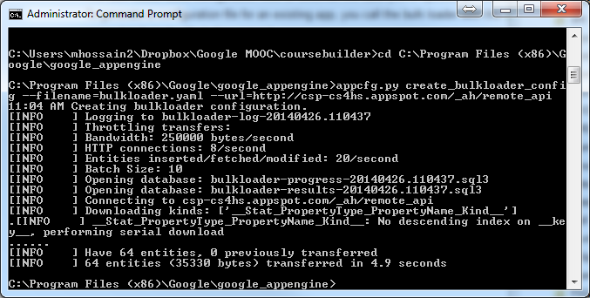

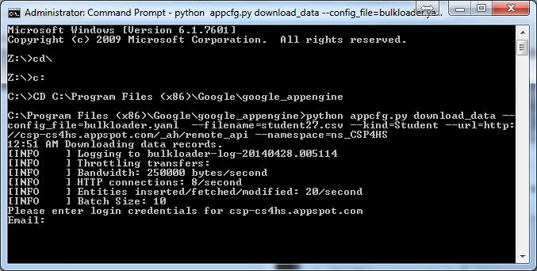

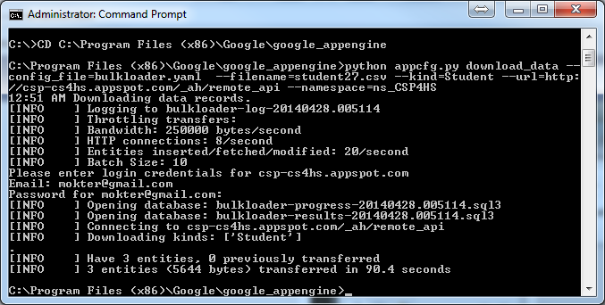

<https://developers.google.com/appengine/docs/python/tools/uploadingdata#Python_Using_automatic_configuration>

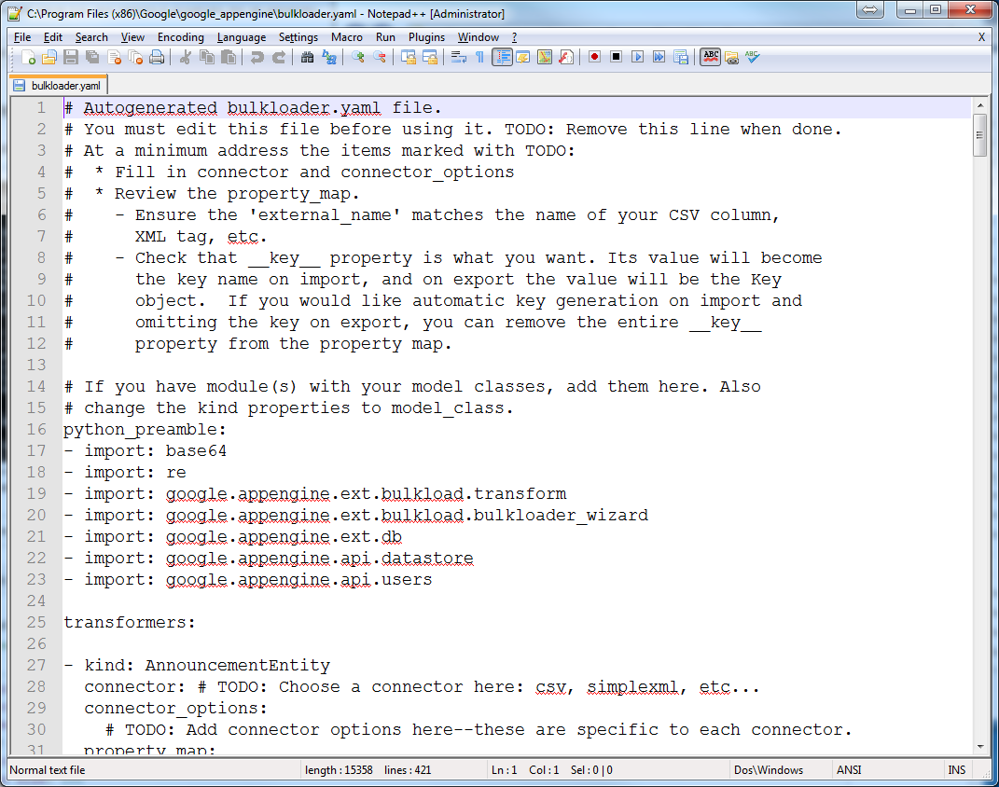

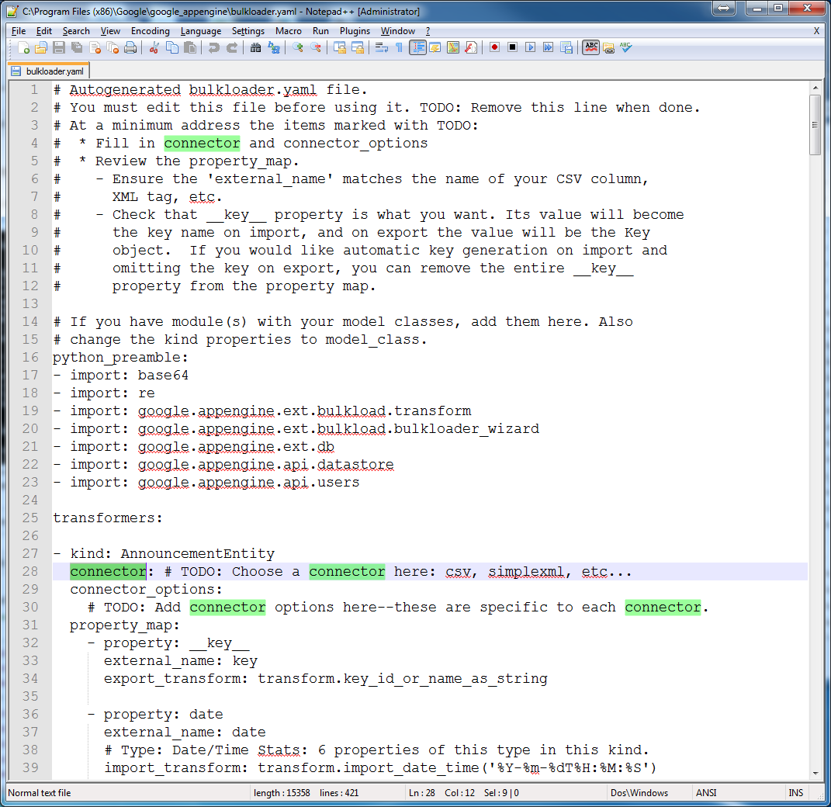

**Editing the autogenerated bulkloader.yaml file**

**I put placed**  connector type as “csv” i**n 15 places as follows, but dit not put anything in the** connector_options:

These were as follows:

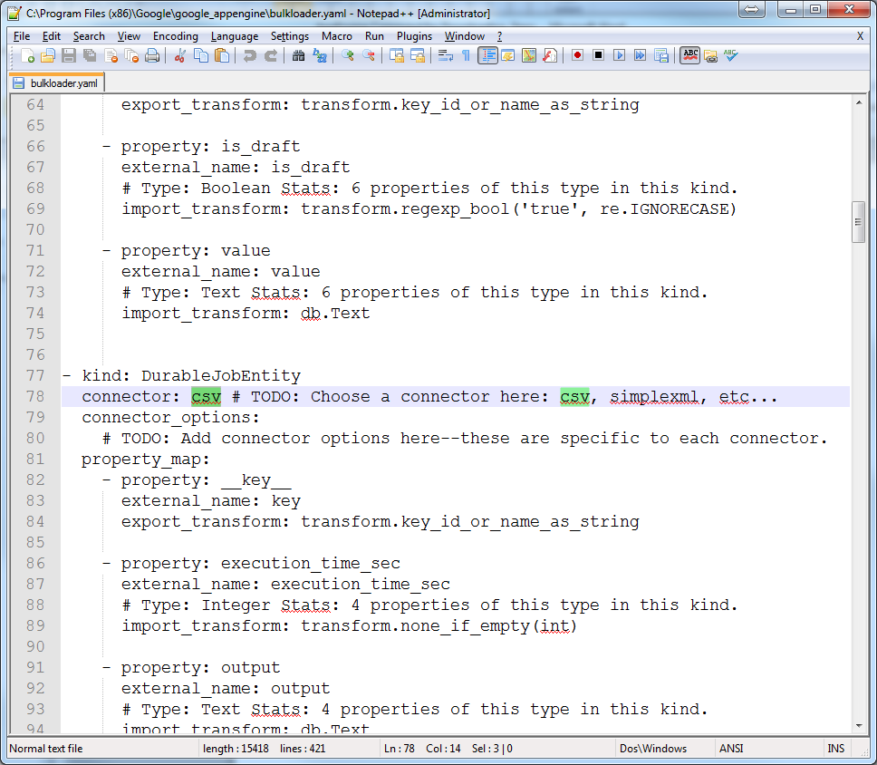

I Also Changed:

import_transform: transform.create_foreign_key('TODO: fill in Kind name')

as

import_transform: transform.create_foreign_key('Reviewee')

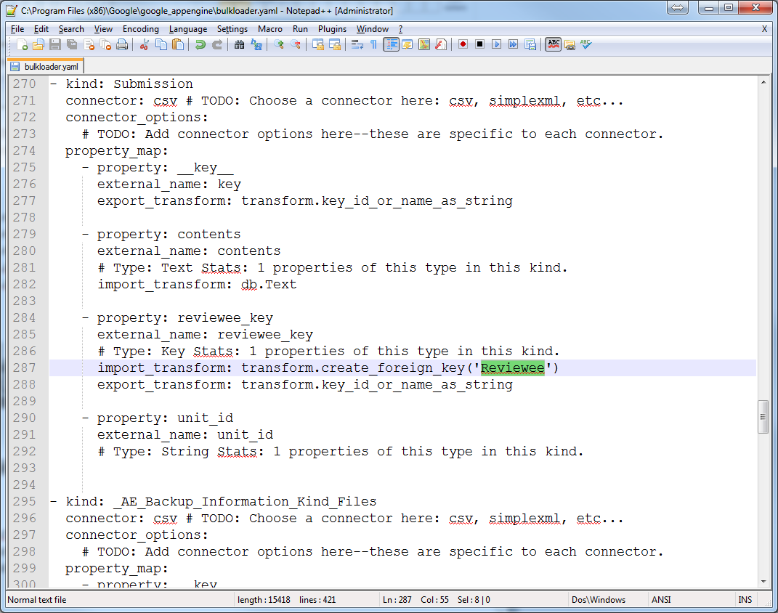

With the Edited bulkloader.yaml file I then executed the following command:

python appcfg.py download_data --config_file=bulkloader.yaml --filename=student.csv --kind=Student --url=http://csp-cs4hs.appspot.com/_ah/remote_api --namespace=ns_CSP4HS

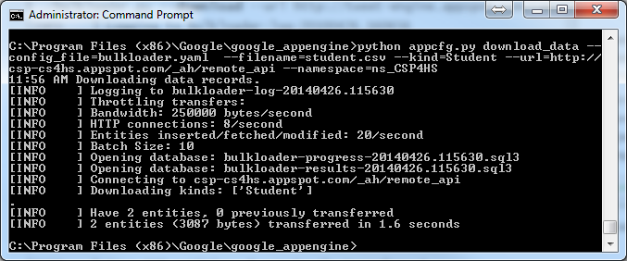

It created a student.csv file in my “C:\Program Files (x86)\Google\google_appengine” folder as follows:

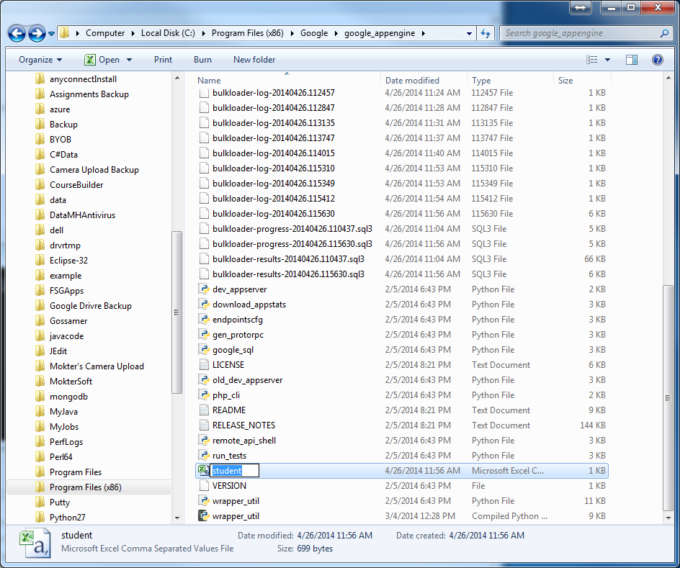

Now I opend it with MS Excel and found the registered studeets as follows:

